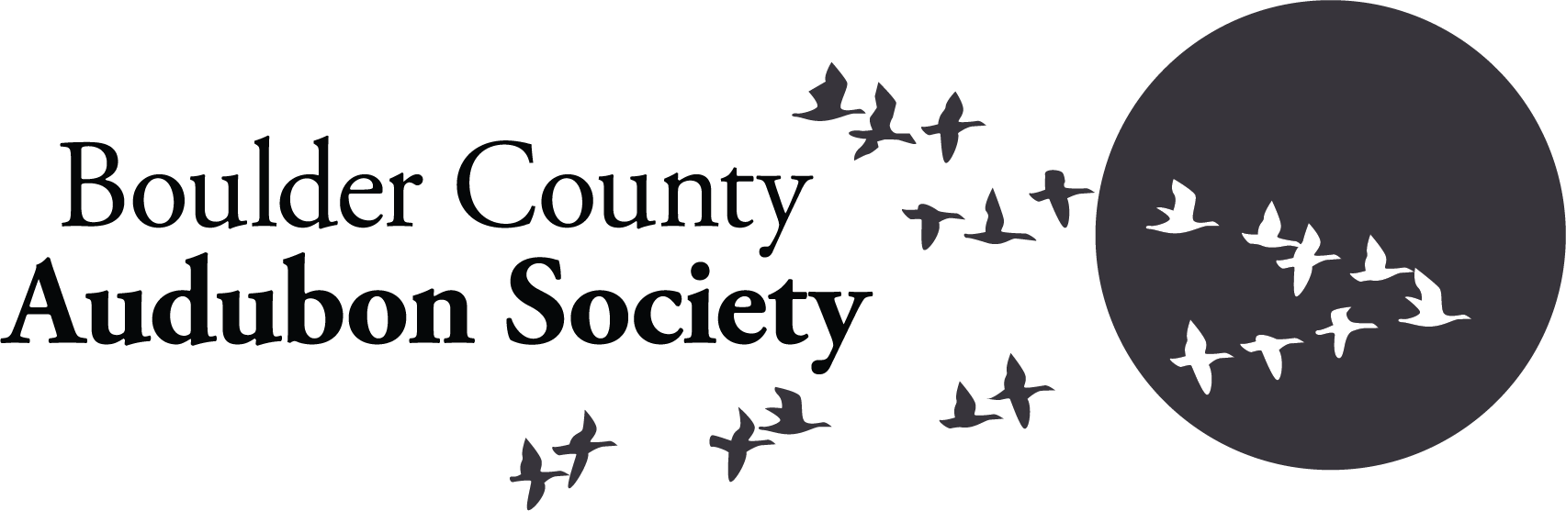
Teen Birding Camp Scholarship Application Form
Coastal Maine Bird Studies (Session Two): June 16-21, 2024

Scholarship application deadline is February 1, 2024
Name:
Birthdate:
Address:
E-Mail and Phone:
Parent/Guardian's Name:
Email and Phone:

- I agree to the following conditions: (Initial on the line before each statement).

___ I understand that I am responsible for arranging my own transportation to and from the Portland, Maine airport. These transportation arrangements must be completed and provided to Boulder County Audubon by April 15, 2024. Reimbursement of travel expenses up to $600 is available only after I have completed the program. (If these travel costs will prevent me from attending the camp, I can discuss with the Boulder Country Audubon Education Committee about upfront reimbursement of these costs.)

___ I have read and agree to the Audubon Camp Covid-19 Guidelines.
https://hogisland.audubon.org/covid-19guidelines

___ After completion of the camp, I agree to write a short article for the Boulder County Audubon newsletter describing my experience and/or give a short presentation at a Boulder County Audubon monthly meeting.

___ I have discussed the scholarship program with my parent(s) or guardian(s), and they approve of my applying for the scholarship.

II. Submit a 150-250 word essay describing your reasons for applying for the scholarship. Include one paragraph addressing each of the following questions:

- What appeals to you about this camp? What do you hope to get out of the experience?
- What is your previous experience or interest in ecology or ornithology, including experiences you've had either in the classroom or outside it?
- How will the scholarship make it possible for you to attend this camp?

III. Ask a current or former teacher or mentor to provide a letter of recommendation for you. These can be emailed by the recommender to the email or address listed below. Courtesy suggests asking for the letter of recommendation at least 3 weeks before it is due. You will want to follow up with the person to make sure they submit the letter by the deadline.

Scholarship application deadline is February 1, 2024. Scholarship recipients will be notified by February 28, 2024.

To submit, email this completed form and your essay to scholarship@boulderaudubon.org with the subject line “Hog Island Scholarship”. Or mail this completed form and the essay to:
Audubon Scholarships, PO Box 2081, Boulder CO 80306.
If mailing, please email scholarship@boulderaudubon.org that you are applying.

